

SCHOOL *of* BUSINESS AND TECHNOLOGY

Department of Engineering and Aviation Sciences

**Design of Autonomous Food Delivery Vehicle**

**Kevin Harper**

Advisor: Dr. Zhang

July. 22, 2020

Design of Autonomous Food Delivery Vehicle

By

Kevin Harper

Submitted to the Department of Engineering and Aviation Sciences in partial fulfillment of the requirements for the degree of Bachelor of Science in Engineering at the

UNIVERSITY OF MARYLAND EASTERN SHORE

Date

The author hereby grants the University of Maryland Eastern Shore permission to reproduce and distribute publicly, paper and or electronic copies of this document in whole or in parts.

Authors Kevin Harper

Signature Kevin Harper

Date July 22, 2020

Department of Engineering and Aviation Sciences

Certified by

List of Contents

List of Contents 3

List of Figures 2

List of Tables 3

Chapter 1. Introduction 4

1.1 Background/Motivation 4

1.2 Objective 5

Chapter 2. Implementation Plan 6

2.1 Tasks 6

Chapter 3. Implementation 7

3.1 Implementation of Task 1 & 6 . 7

List of Figures

Figure. 1. Starship Robot designed by Starship Technologies 4

Figure. 2. Solidworks cupholder 6

Figure. 3. google maps api test code………………………………………………………………………………………….7

Figure. 4. mission planner………………………………………………………………………………………………………..8

Figure 5. Mission Planner sample document………………………………………………………......................9

Figure 6. Mission planner test documet………………………………………………………………………………….9

Figure 7 Court plaza Mission Planner…………………………………………………………………………………………….10

Figure 8. Google satelite maps on google MyMaps………………………………………………………………12

Figure 9. Add directions icon for MyMaps……………………………………………………………………………12

Figure 10. Input directions for point A and point B……………………………………………………………….13

Figure 11. Show the directions of the map once inputted…………………………………………………….13

Figure 12. How to export the map into KML/KMZ format………………………………………………………14

Figure 13. Icon to export map………………………………………………………………………………………………..14

Figure 14. Export option and download………………………………………………………………………………..15

Figure 15. Uploading the KML file to Mission Planner…………………………………………………………..15

Figure 16. Court Plaza route………………………………………………………………………………………………….16

List of Tables

**No table of figures entries found.**

1. Introduction

Autonomous self-driving vehicles are growing exponentially in popularity within new-age technology. There are only a few level 5 self-driving vehicles that require no human activation to drive. These self-driving cars are being used to transport goods and people around the world. Furthermore, the electric car is preferred more often because it offers economic, global, and environmental benefits. The car will be planed and designed to deliver food to people autonomously.

## Background/Motivation

On the campus of the University of Maryland Eastern Shore, there are many students that worry about their next meal and how they are going to get hold of it in a timely fashion. A college student has numerous responsibilities on their table, which limits their ability to obtain food at an ideal time. Throughout an average college student's day, they might have at least 3 to 6 classes per day, extracurricular activities if they are an athlete or in some type of group, and they must study to stay on top of their grades. Furthermore, most colleges have freshmen who are not allowed to have cars. And if any student who drives a car must pay a lot of money for parking and fees. This limits the number of college students with cars and increases the number of college students walking around campus. “Among the 214 National Universities that reported these data to U.S. News in an annual survey, the average percentage of students who brought cars to campus in the 2016-2017 academic year was 46.8 percent.”

When college students are in their dorm after a long day of classes and stressful lecturing. They still must do homework and study for their classes. At that point, they are tired of walking and going to get some food that is at least .4 miles away. The combination of the gruesome schedule of college students makes and the tireless walking around campus makes it hard for college students to eat food when it is offered.

What if it was possible to send Campus Universities dining services to students around their dorm room or any location they might possibly be located. This would allow campus living students to have the option to not worry about receiving food without stopping their homework and walking half a mile to their cafeteria or dining services. Autonomous Food Delivery System can be created to deliver food around the campus to any recipient, preferably college students living on campus.

At the University of Maryland Eastern Shore students are offered food at the locations including Students Service Center, Engineering & Aviation Sciences Complex, Hawk’s Nest, Waters Hall. In the Students Service Center, they offer students plateau dining and oasis staff dining. The UMES campus offers food, but they have no form of delivery options for students to receive food on campus. Furthermore, college students often argue and complain about the food they receive from the cafeteria. This leads them to eat the food that the university provides or any other dining services other than the cafeteria options. There should also be an option for students to choose the food they want to receive via delivery options. Instead of dreading the taste of the food they hate, they can designate their specified food to come to their location.

The idea of creating an autonomous food delivery car was sparked by the Starship Delivery Robot. As shown in Figure1, The Starship Robot is a six-wheeled ground robot that can navigate streets and sidewalks, where they offer on-demand package delivery for consumers and businesses. The Starship Robot was created and operated by Starship Technologies in July 2014.

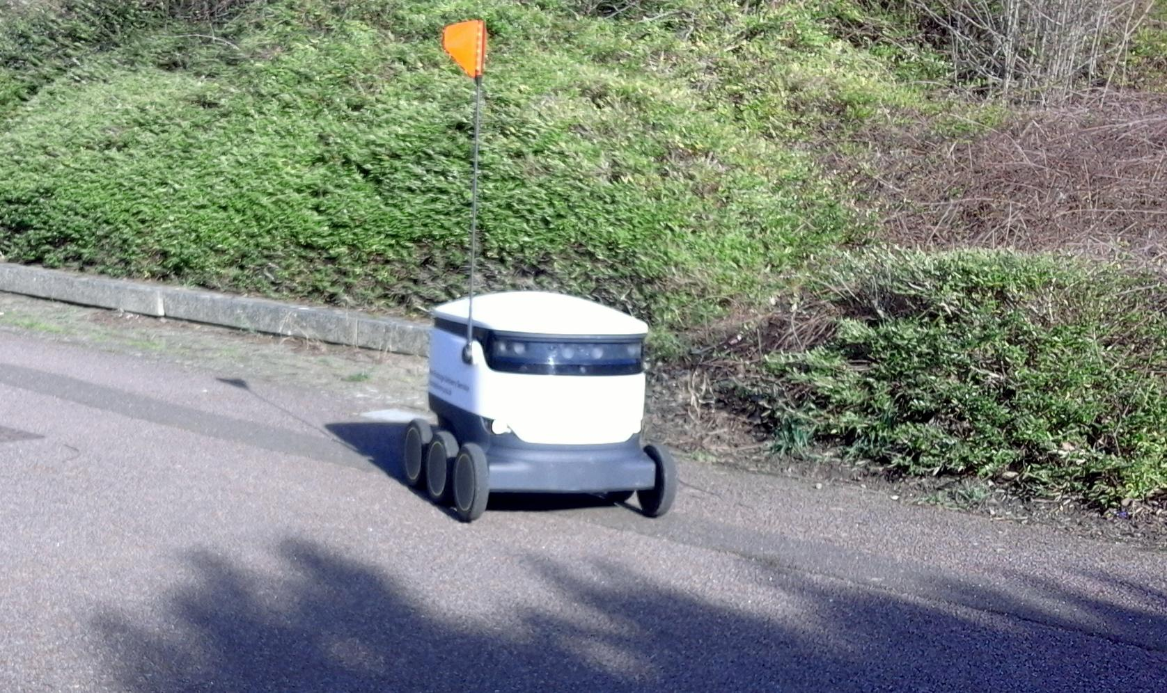

1. Starship Robot designed by Starship Technologies

## Objective

Design an Autonomous Electric Car that can deliver dining services around Campus Universities.

1. Implementation Plan

## Tasks

Task1: Vehicle Structural Design

Subtask 1.1: CAD of Structure

Subtask 1.2: Implement Structure

Subtask 1.3: Design Lock System

Task 2: Design of Electrical Power System

Subtask 2.1: Identify electrical components

Subtask 2.2: Connect Components

Subtask 2.3: ESC configuration with Arduino

Task 3: APP Design

Subtask 3.1: Create Ordering System

Subtask 3.2: Design Payment System

Subtask 3.3: Design Food Tracking System

Subtask 3.4: Design SMS

Task 4: Design of the Artificial Intelligence System

Subtask 4.1: Design Semantic Segmentation for System

4.1.1: Gather Dataset

4.1.2: Build Semantic Segmentation Model

4.1.3: Train Model

4.1.4: Test and Evaluate Model

Subtask 4.2: Detection

4.2.1: Deploy Pre-Trained Model to Raspberry Pi

4.2.2: Design Motion Control Guidelines

4.3.3: Design Serial Communication Protocol

Task 5: Design LIDAR System

Subtask 5.1: Design Program for LIDAR sensor

Subtask 5.2: Design connection for LIDAR sensor

Subtask 5.3: Send control and steering commands

Task 6: Navigation

Subtask 6.1: Extract Geographic Coordinate Units

Subtask 6.2: Configure GPS on Arduino

Subtask 6.3: Configure Compass on Arduino

Task 7: System Testing, evaluation, and enhancement

Subtask 7.1: Test Design Requirements

Subtask 7.2: Evaluate and apply changes if necessary

Subtask 7.3: Repeat process

1. Implementation

## Implementation of Task 1.1.

*3.1.1. Implementation of Subtask 1.1*

Using SolidWorks , figure,  2 & 3,  is the design of the cup holder that will be placed inside the food compartment of the vehicle. We will 3D print this figure and place it catercorner and either glued down or screwed down in the food compartment. The size of this cup holder will be able to fit a Large Size drink snuggly, smaller sizes will also be able to be placed inside the cup holder. The design was made like this so that even smaller drinks will not flip over and spill inside the vehicle.

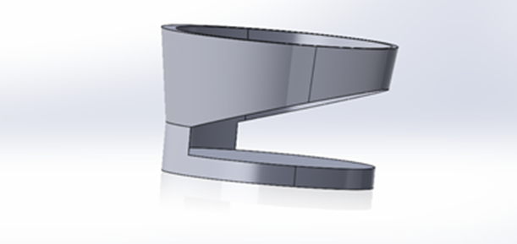

*Figure 2*

## Implementation of Task 6

*For task 6, the goal was to consider how this car is going to be able to navigate from point A to point B to be able to make its food deliveries.*

The First solution idea that was looked into is accessing using Google Maps platform “Google API”. Google API gives access to their satellite and the ability to create a set of waypoints/directions. Google API allows up to 25 waypoints for your personal use. In the code below, there is an example of these directions are called on upon using an “API” key. When the code is entered below, Google Maps GPS pulls up a menu where the destination can be set and also places in between that destination. For the vehicle this project is using, the goal is to have it to travel along the confines of campus, so with google API there is an option to differentiate between an “DRIVING” or “WALKING” route. For this project a walking route will be used because that would avoid the car going on the road.

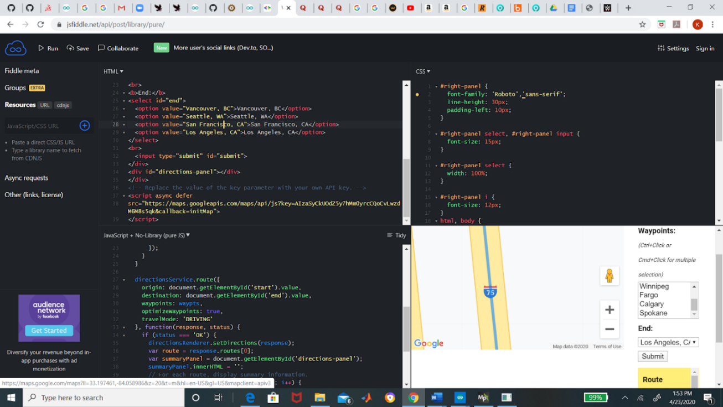

Figure 3: Google API code

The goal was to take the data that was given from the Google API and interface with another software. the software is called “Mission Planner”. Mission Planner (Figure 6) is an application that is created by the company “Ardupilot”, this application that allows access the google satellite maps and used that map to create waypoints or route missions by clicking different points of that maps. Once a mission is created , it can be saved and uploaded anytime. Mission planner gives the ability to configure their software with any rover vehicle , once it is interfaced with a rover, a saved mission/route can be uploaded .

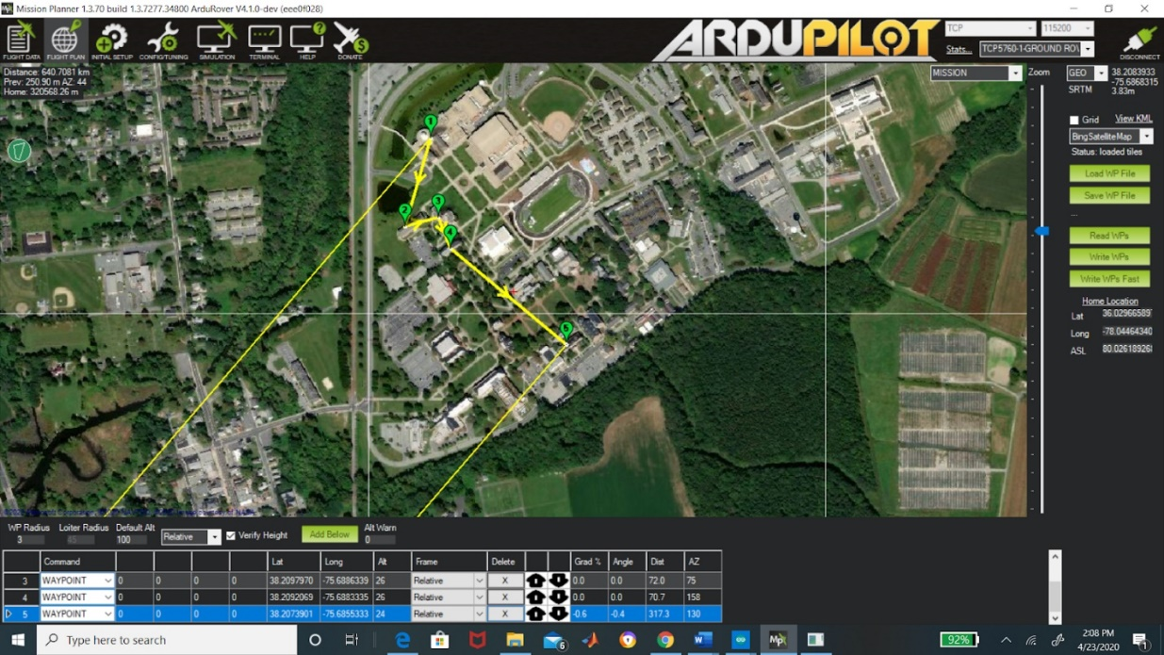

Figure 4:Mission Planner

In the process, there was a issue between configuring the google maps API and the mission planner. There had to be more thought process on what would be the best possible solution to upload a route on Mission Planner, after some more research, another possible solution to the problem was to find a way upload to upload coordinate points that will be able to tell the our rover how to get from point A to Point B in the safest , most efficient route.

The way to do this is to edit a text document , the Ardrupilot website has a template(figure 7) for how this file should be formatted so that Mission Planner can be able to read and execute a document. Using the template, an example will be below in figure 8, will show the coordinates for a delivery route from the SSC to Court Plaza

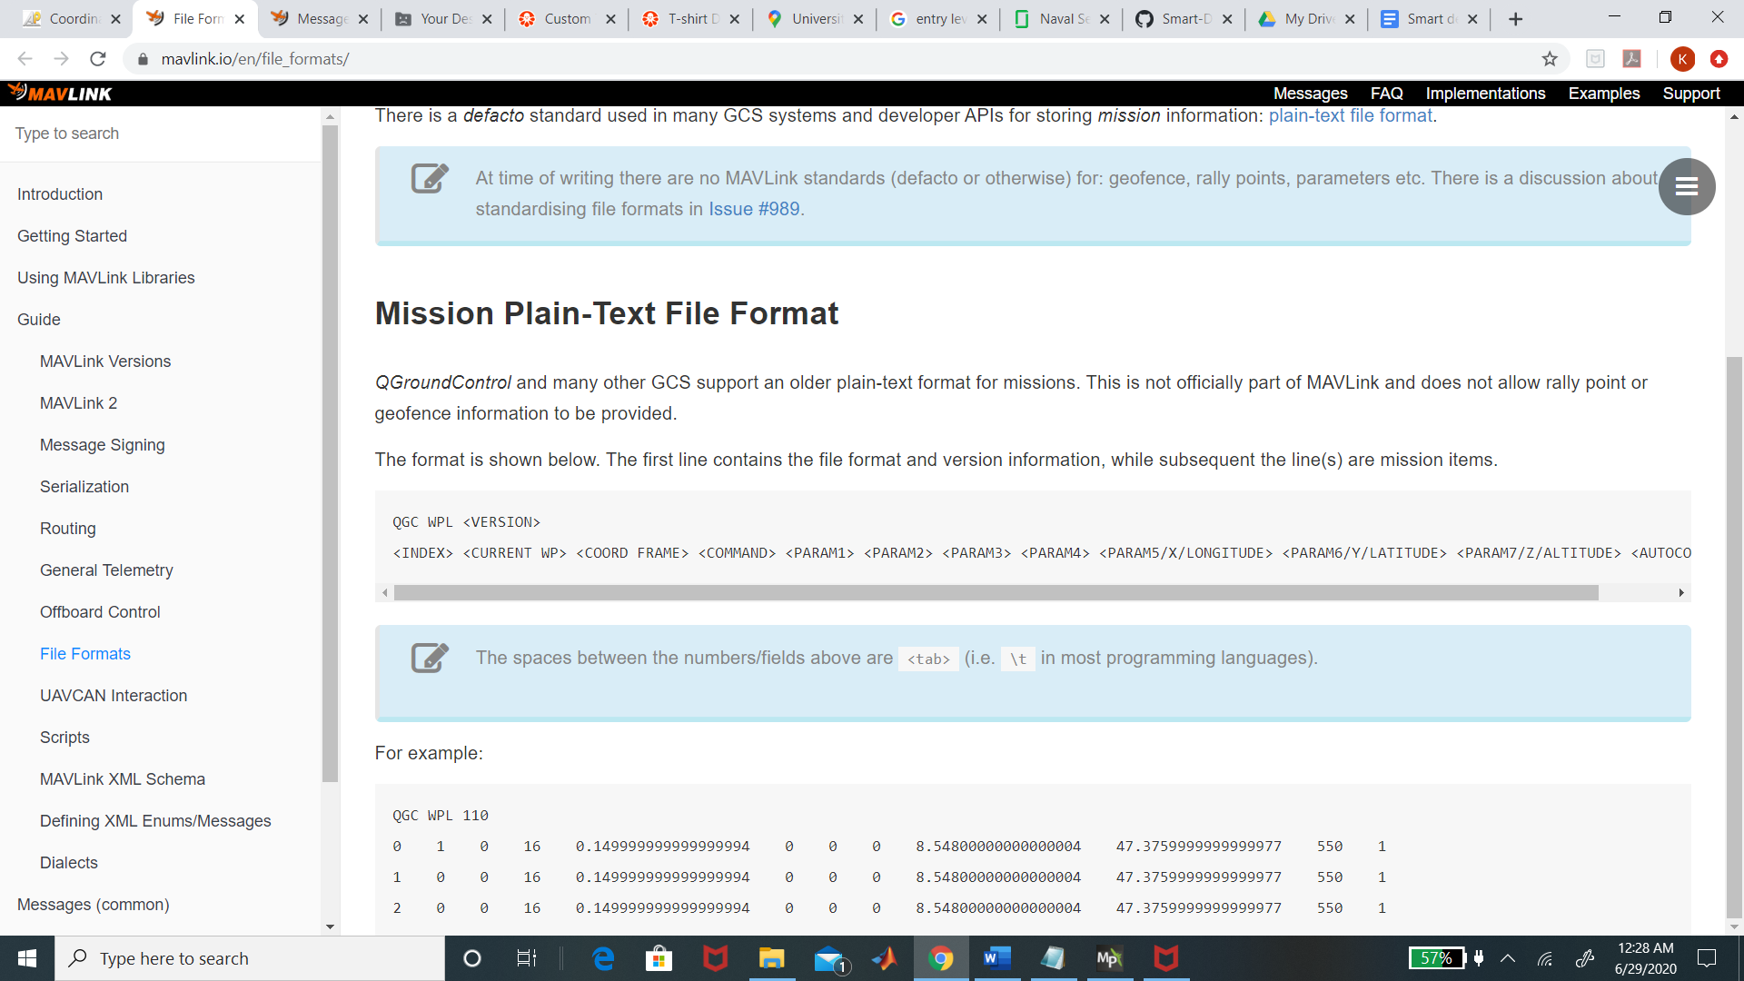

Figure 5: mission planner template

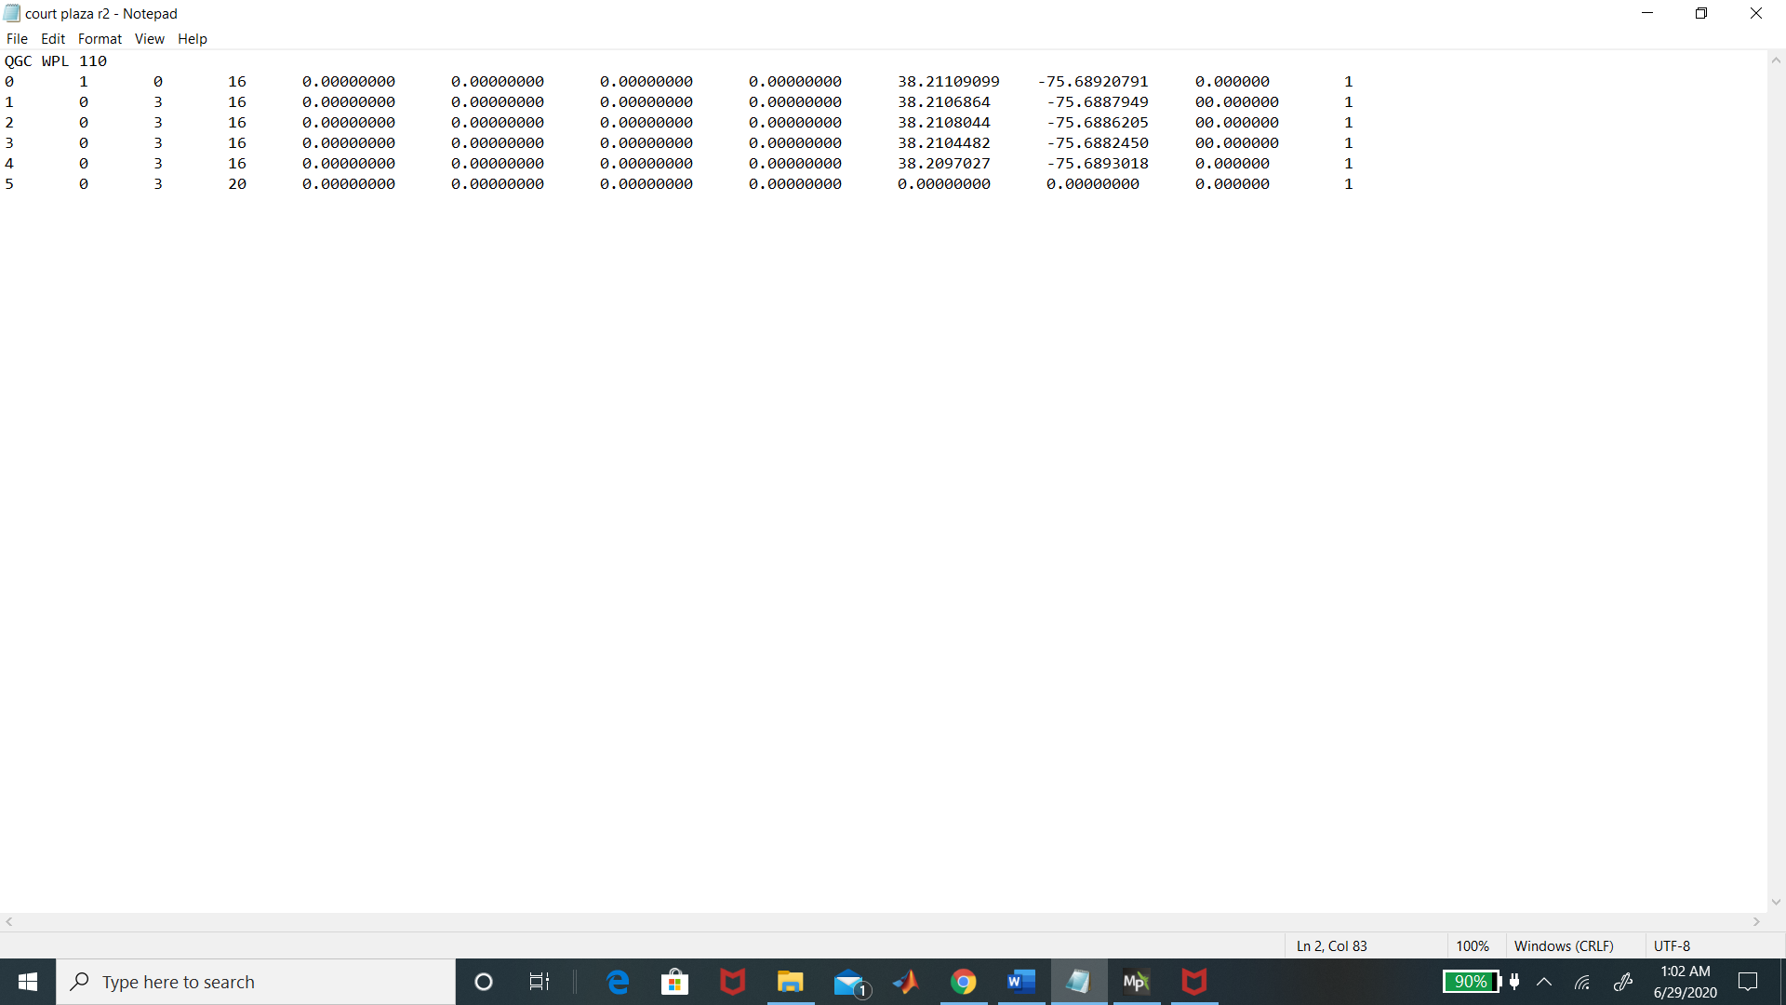Figure 6: mission planner template

The first column represents which number waypoint we are on, that will help order the directions the vehicle will be taking on its route. In the first row , there is a number 0 followed by a number 1, this establishes that this is the home location and not a waypoint , the number 3 is in the 3rd column is the radius of our waypoints. In the 4th column , this column is to give the vehicle commands given by specific code numbers that Mission Planner recognizes. So in the first four rows, there is the number 16, which means “waypoint” , which tells the rover once this waypoint is reached then navigate to the next waypoint . The last column , has the number 20 in it , this number is telling the vehicle to return to its home location and that the mission is complete. Column 5-8 have zeros in them because of the command that we have given there is no value that needs to be placed there . Then after those columns, then we fill in our coordinates for the home location and our waypoints. After those column, you have a column for altitude but since we have a rover and not a drone/plane, zeros are the values for this column.

When placing coordinate points , consideration about the differences of how humans are able to read directions and how google maps is able to tell when to turn left or right and how the car would not be able to understand a GPS the way it can , had to be accounted for. So when putting together my points, Coordinates were picked based on where the vehicle will have to turn to be able to make it to its desired location . Figure 9 below shows what the text document (figure 9) looks like when uploaded to mission planner.

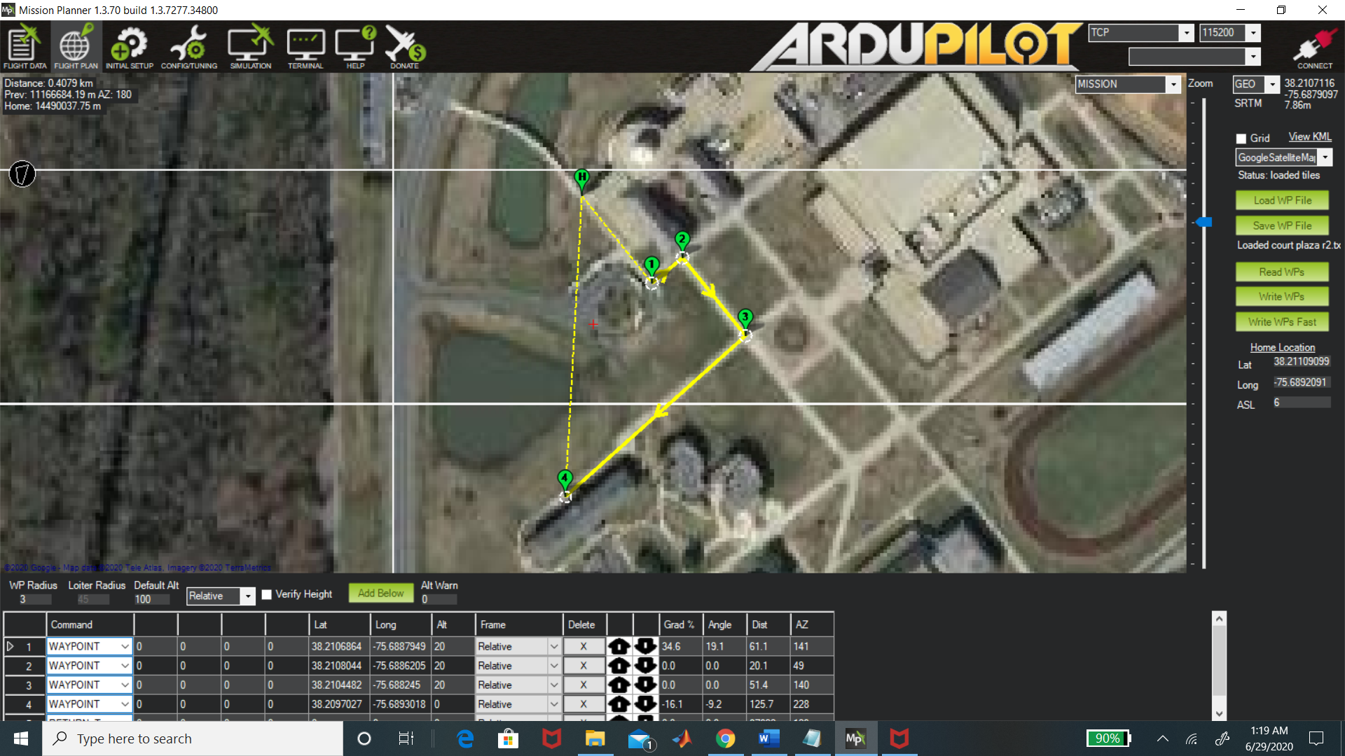

Figure 7: Court plaza route using template

Coming across this solution, which was a step in the right direction, there was still a feeling of something better being out there. This solution would be configuring Mission Planner with another Google application, “Google My Maps “. My Maps allows an user to see a satellite map as shown in figure 10, once the map is shown, there is a to add direction to the map (figure 11) . Once the add directions icon is selected, there is a textbox where a start point(A) and an end point(B) can be placed(figure 12). There is also an option to add another direction or stop along this route which would be represented as point C . Once the directions are placed, then it will be shown on the map (figure 13). The map can be adjusted as well by dragging the blue to the location that is preferred. Once the map and directions are set, there is a way to download these coordinates/directions of this map. It can be done by right clicking inside the directions menu (figure 14) and then click on were it says “Export to KML/KMZ” (figure 15). And check the box that says “Export as KML instead of KMZ….”and press the download icon (figure 16) . The KML should break down all the coordinates point along the route that was generated. After that, a user should open the mission planner application, then select the “plan icon” in the top left hand corner . Next would be to right click on the map and select file “load/save” and press “load KML file” (figure 17). Then upload the saved route and an example of an uploaded route will be shown in figure 18.

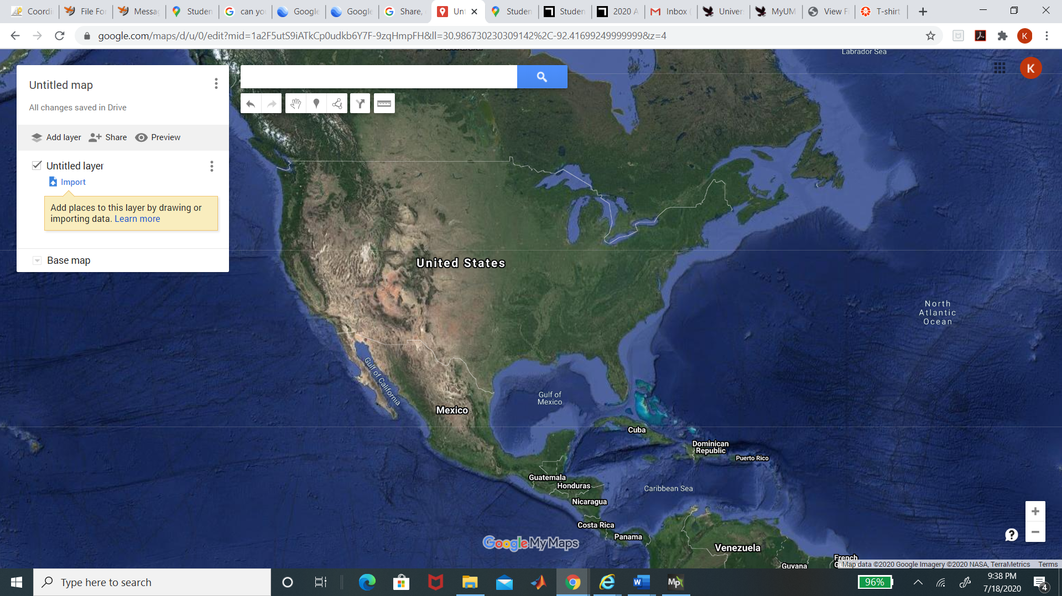

Figure 8: Google satellite map from Google MyMaps

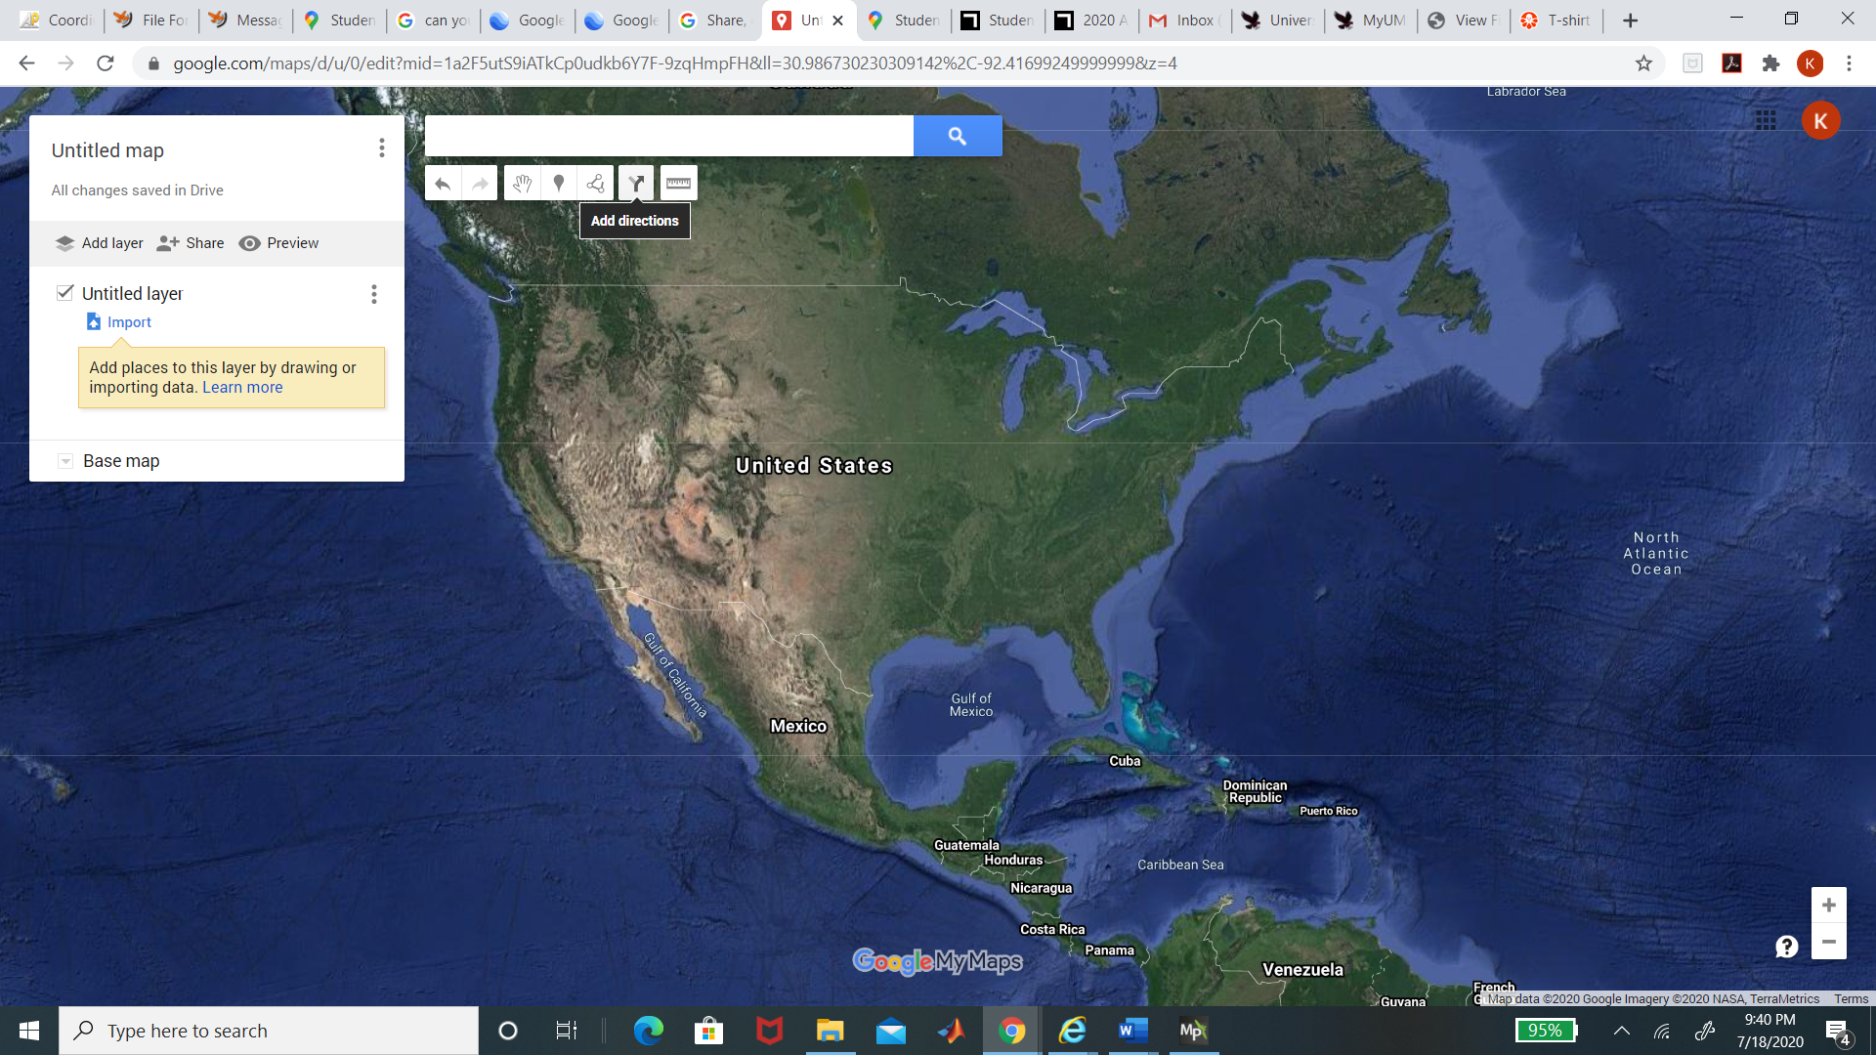

Figure 9: Add directions icon is hovered in this figure

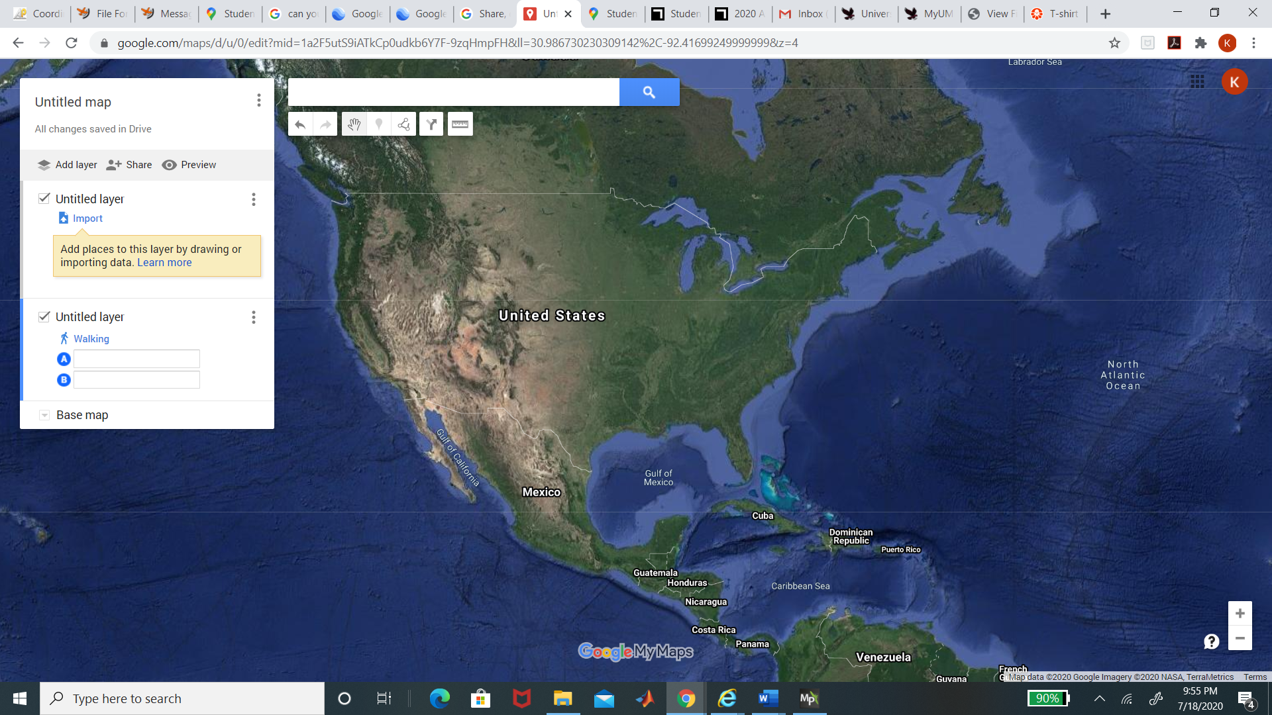

Figure 10: shows where a user can insert directions in point A & B

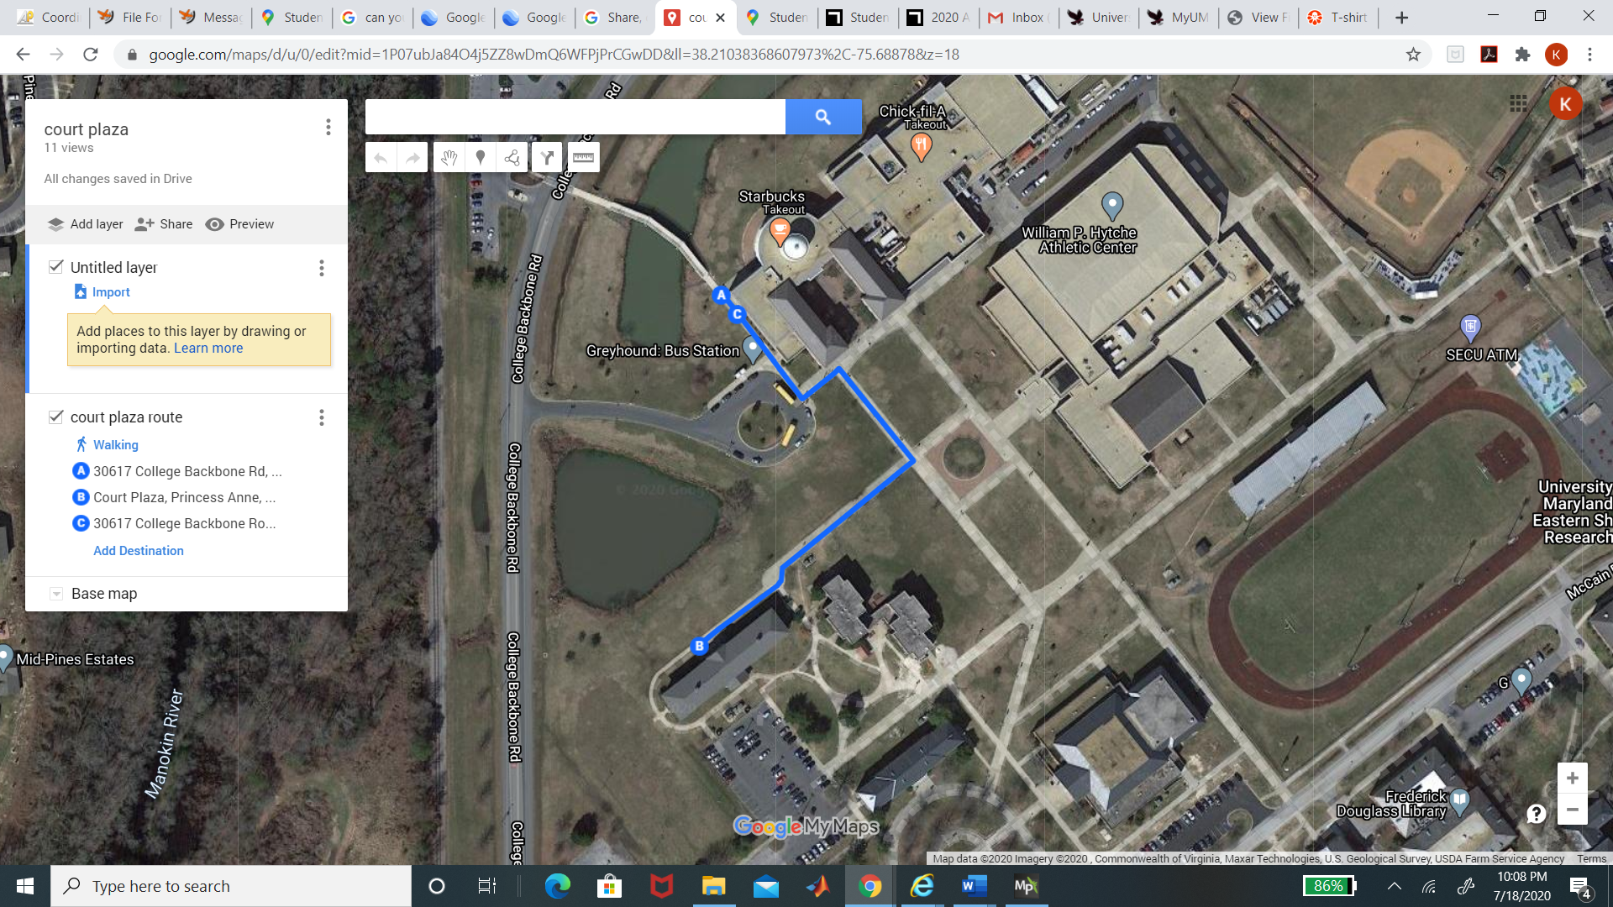

Figure 11: shows the maps once the directions are placed

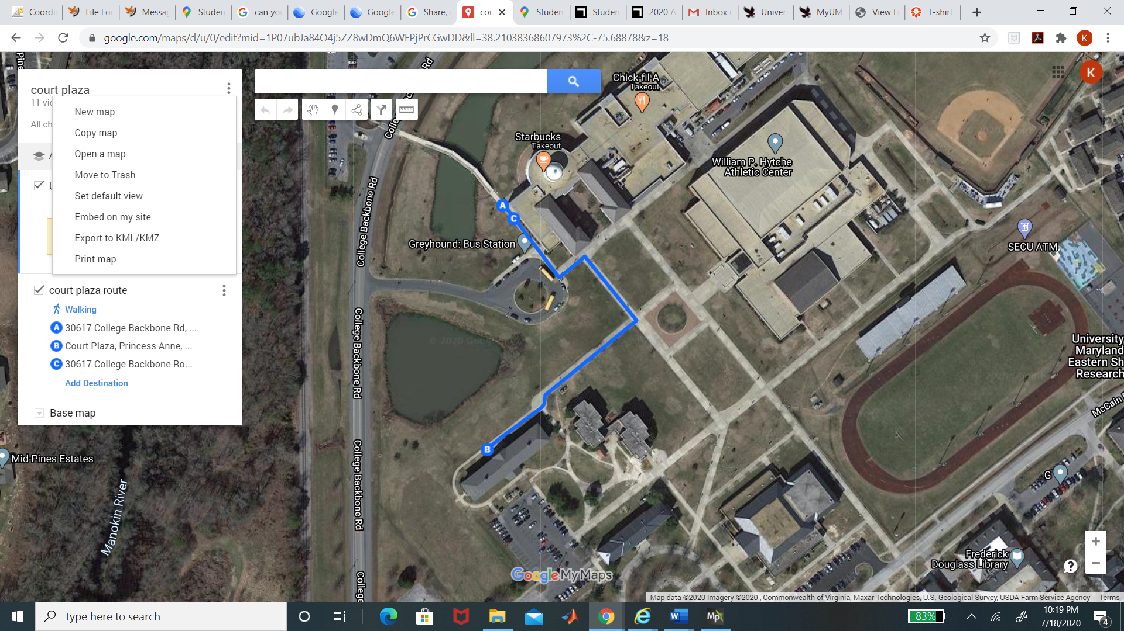

Figure 12: shows the menu where the coordinates can be downloaded

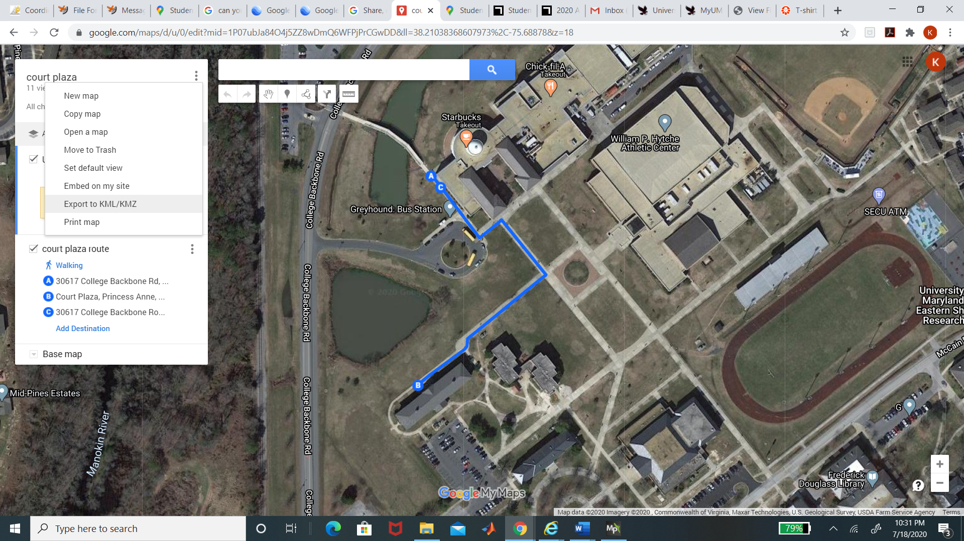

Figure 13: A user should select “Export to KML/KMZ”

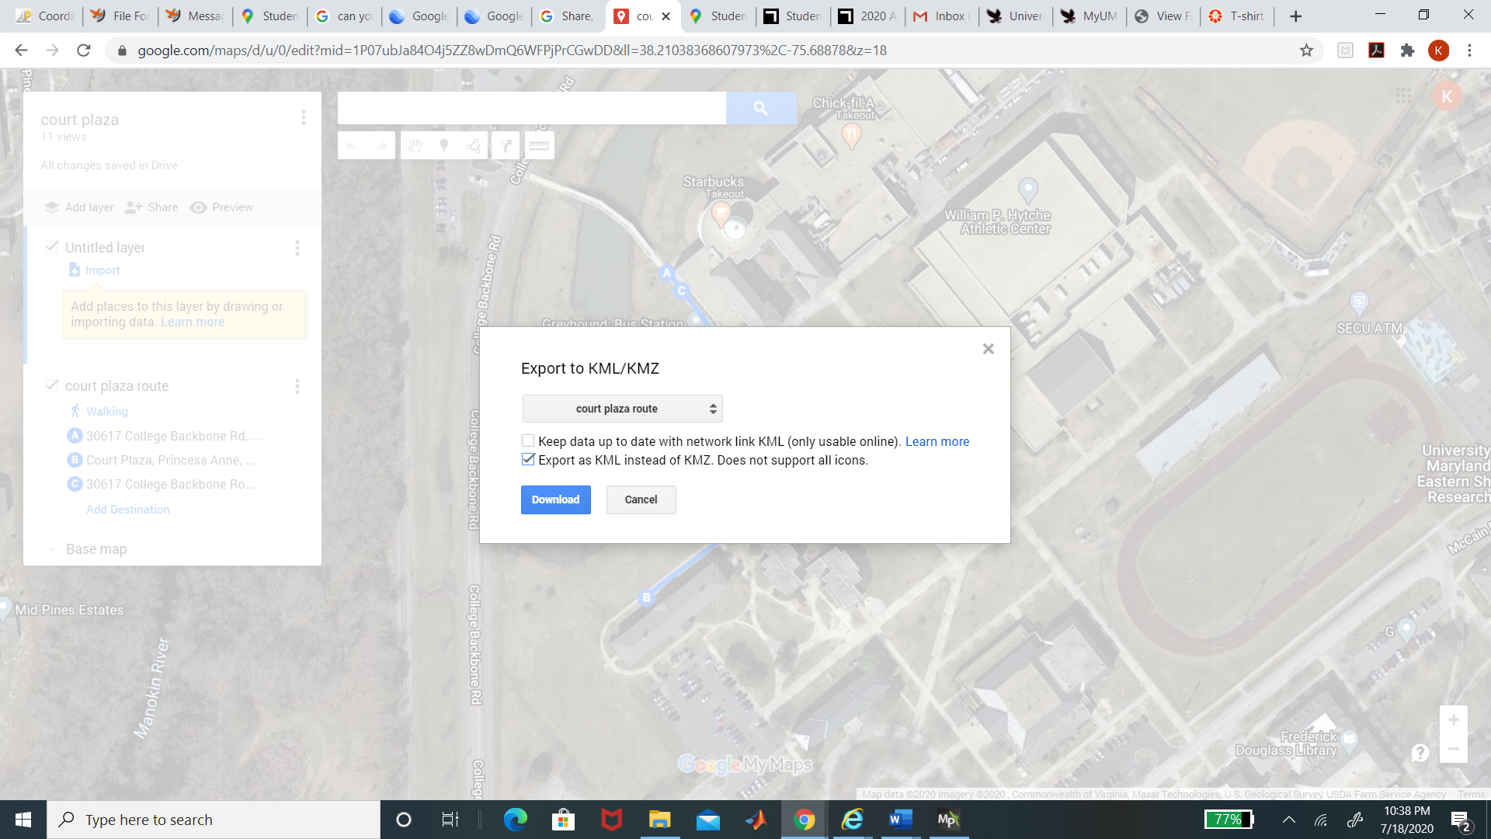

Figure 14 : a user should click the export box then press download

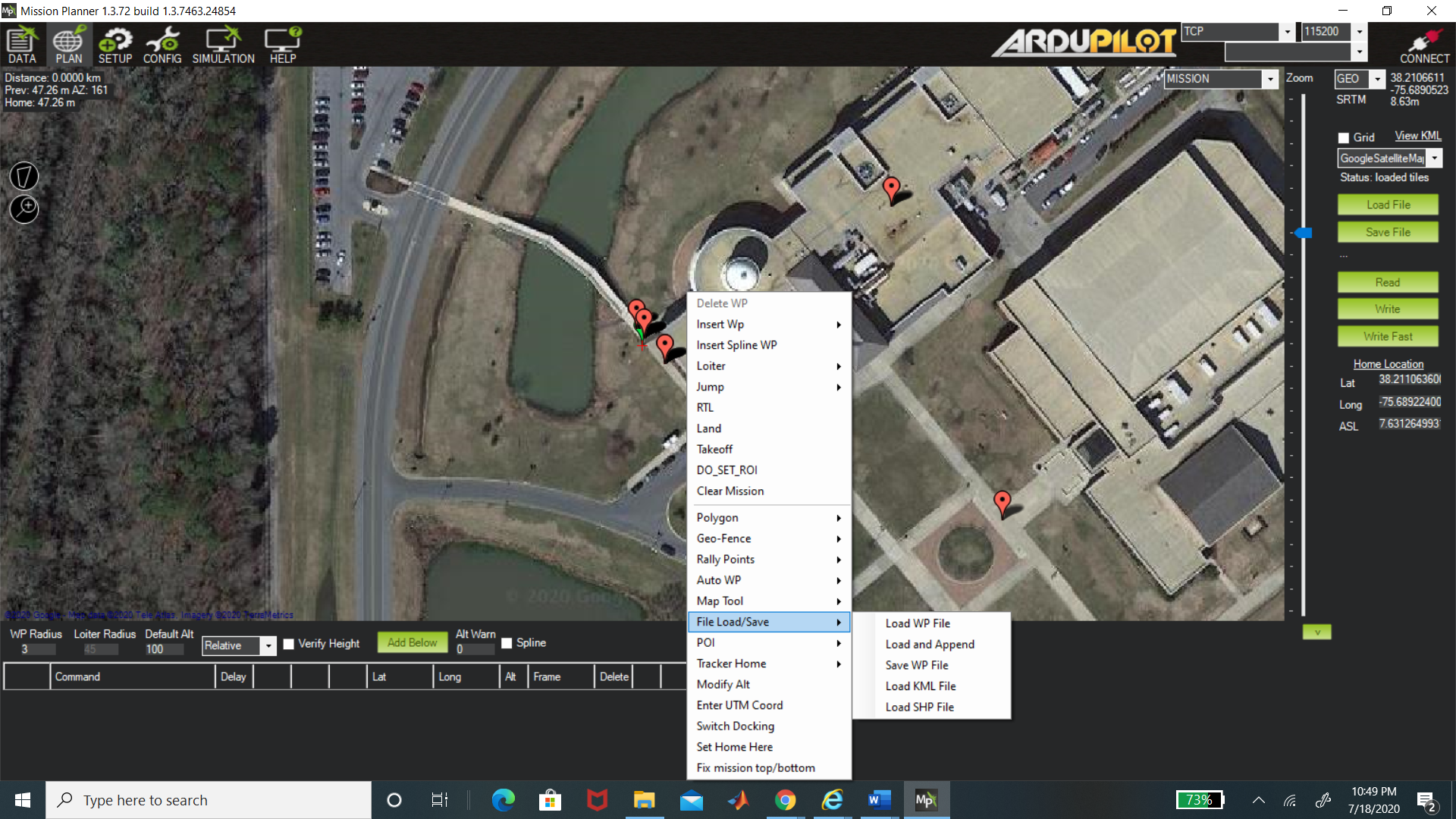

Figure 15: After right clicking the menu, press the load KML file option

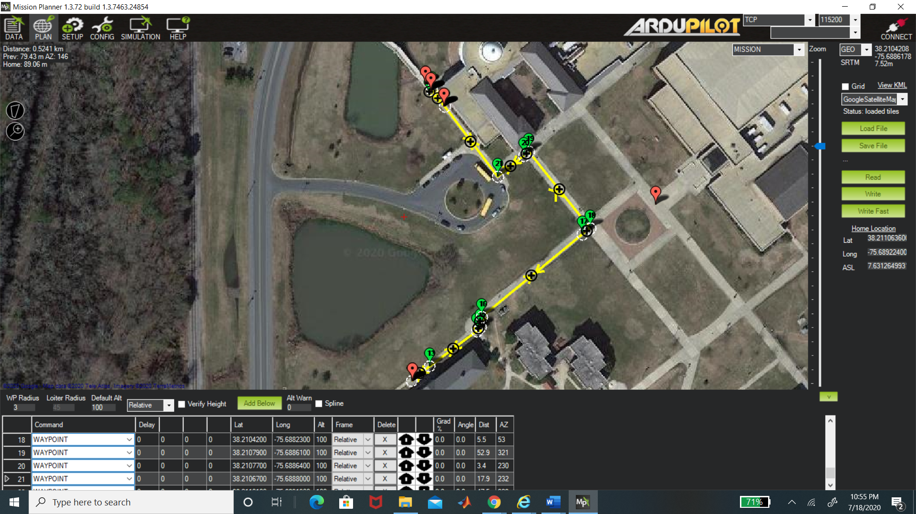

Figure 16: Route to Court Plaza using MyMaps on Mission Planner

Using this method, routes can be created for any other locations on the UMES campus and it will save the user the trouble of having to manually click on spots on the map when using Mission Planner.

Appenedix